附件
2025年3月31日世界知识产权组织国际局通报的
78件国家徽记、官方检验印章、国旗等徽记

序号 | 国际局编号 | 国家 | 地址 | 类别 | 标志
1 | GB91 | 英国 | Intellectual Property Office - Concept House - Cardiff Road Newport South Wales NP10 8QQ  United Kingdom | 国家徽记 | 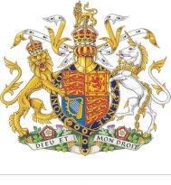
2 | GB92 | 英国 | Intellectual Property Office - Concept House - Cardiff Road Newport South Wales NP10 8QQ  United Kingdom | 国家徽记 | 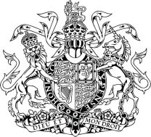
3 | GB93 | 英国 | Intellectual Property Office - Concept House - Cardiff Road Newport South Wales NP10 8QQ  United Kingdom | 国家徽记 | 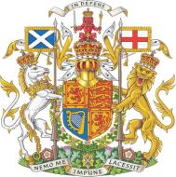
4 | GB94 | 英国 | Intellectual Property Office - Concept House - Cardiff Road Newport South Wales NP10 8QQ  United Kingdom | 国家徽记 | 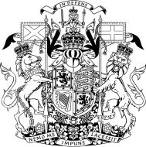
5 | GB95 | 英国 | Intellectual Property Office - Concept House - Cardiff Road Newport South Wales NP10 8QQ  United Kingdom | 国家徽记 | 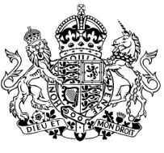
6 | GB96 | 英国 | Intellectual Property Office - Concept House - Cardiff Road Newport South Wales NP10 8QQ  United Kingdom | 国家徽记 | 
7 | GB97 | 英国 | Intellectual Property Office - Concept House - Cardiff Road Newport South Wales NP10 8QQ  United Kingdom | 国家徽记 | 
8 | GB98 | 英国 | Intellectual Property Office - Concept House - Cardiff Road Newport South Wales NP10 8QQ  United Kingdom | 国家徽记 | 
9 | GB99 | 英国 | Intellectual Property Office - Concept House - Cardiff Road Newport South Wales NP10 8QQ  United Kingdom | 国家徽记 | 
10 | GB100 | 英国 | Intellectual Property Office - Concept House - Cardiff Road Newport South Wales NP10 8QQ  United Kingdom | 国家徽记 | 
11 | GB101 | 英国 | Intellectual Property Office - Concept House - Cardiff Road Newport South Wales NP10 8QQ  United Kingdom | 国家徽记 | 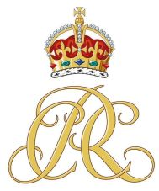
12 | GB102 | 英国 | Intellectual Property Office - Concept House - Cardiff Road Newport South Wales NP10 8QQ  United Kingdom | 国家徽记 | 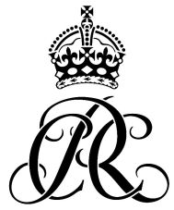
13 | GB103 | 英国 | Intellectual Property Office - Concept House - Cardiff Road Newport South Wales NP10 8QQ  United Kingdom | 国家徽记 | 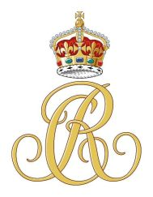
14 | GB104 | 英国 | Intellectual Property Office - Concept House - Cardiff Road Newport South Wales NP10 8QQ  United Kingdom | 国家徽记 | 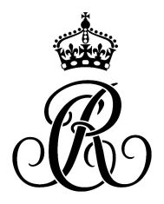
15 | GB105 | 英国 | Intellectual Property Office - Concept House - Cardiff Road Newport South Wales NP10 8QQ  United Kingdom | 国家徽记 | 
16 | GB106 | 英国 | Intellectual Property Office - Concept House - Cardiff Road Newport South Wales NP10 8QQ  United Kingdom | 国家徽记 | 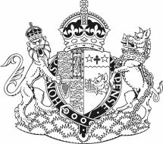
17 | GB107 | 英国 | Intellectual Property Office - Concept House - Cardiff Road Newport South Wales NP10 8QQ  United Kingdom | 国家徽记 | 
18 | GB108 | 英国 | Intellectual Property Office - Concept House - Cardiff Road Newport South Wales NP10 8QQ  United Kingdom | 国家徽记 | 
19 | GB109 | 英国 | Intellectual Property Office - Concept House - Cardiff Road Newport South Wales NP10 8QQ  United Kingdom | 国家徽记 | 
20 | GB110 | 英国 | Intellectual Property Office - Concept House - Cardiff Road Newport South Wales NP10 8QQ  United Kingdom | 国家徽记 | 
21 | GB111 | 英国 | Intellectual Property Office - Concept House - Cardiff Road Newport South Wales NP10 8QQ  United Kingdom | 国家徽记 | 
22 | IT42 | 意大利 | Convention on the Control and Marking of Articles of Precious Metals c/o PIC/S 26, rue de Saint Jean  Geneva  1203  Switzerland | 官方检验印章 | 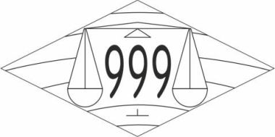
23 | IT43 | 意大利 | Convention on the Control and Marking of Articles of Precious Metals c/o PIC/S 26, rue de Saint Jean  Geneva  1203  Switzerland | 官方检验印章 | 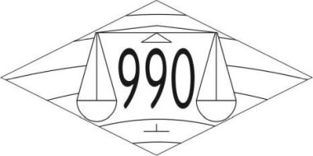
24 | IT44 | 意大利 | Convention on the Control and Marking of Articles of Precious Metals c/o PIC/S 26, rue de Saint Jean  Geneva  1203  Switzerland | 官方检验印章 | 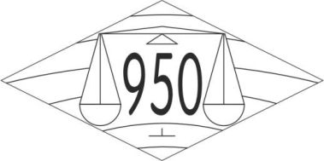
25 | IT45 | 意大利 | Convention on the Control and Marking of Articles of Precious Metals c/o PIC/S 26, rue de Saint Jean  Geneva  1203  Switzerland | 官方检验印章 | 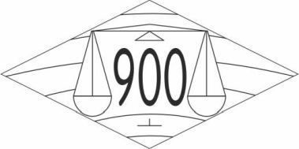
26 | IT46 | 意大利 | Convention on the Control and Marking of Articles of Precious Metals c/o PIC/S 26, rue de Saint Jean  Geneva  1203  Switzerland | 官方检验印章 | 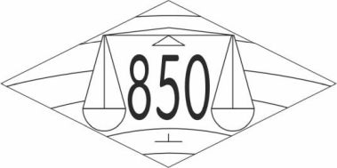
27 | IT47 | 意大利 | Convention on the Control and Marking of Articles of Precious Metals c/o PIC/S 26, rue de Saint Jean  Geneva  1203  Switzerland | 官方检验印章 | 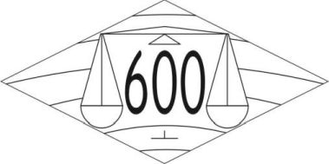
28 | IT48 | 意大利 | Convention on the Control and Marking of Articles of Precious Metals c/o PIC/S 26, rue de Saint Jean  Geneva  1203  Switzerland | 官方检验印章 | 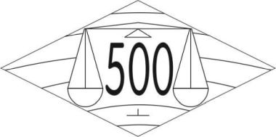
29 | IT49 | 意大利 | Convention on the Control and Marking of Articles of Precious Metals c/o PIC/S 26, rue de Saint Jean  Geneva  1203  Switzerland | 官方检验印章 | 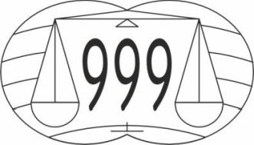
30 | IT50 | 意大利 | Convention on the Control and Marking of Articles of Precious Metals c/o PIC/S 26, rue de Saint Jean  Geneva  1203  Switzerland | 官方检验印章 | 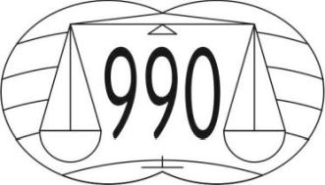
31 | IT51 | 意大利 | Convention on the Control and Marking of Articles of Precious Metals c/o PIC/S 26, rue de Saint Jean  Geneva  1203  Switzerland | 官方检验印章 | 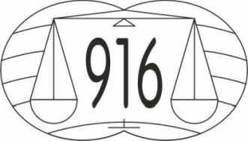
32 | IT52 | 意大利 | Convention on the Control and Marking of Articles of Precious Metals c/o PIC/S 26, rue de Saint Jean  Geneva  1203  Switzerland | 官方检验印章 | 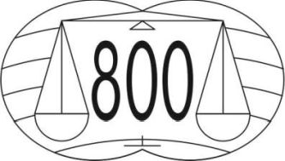
33 | IT53 | 意大利 | Convention on the Control and Marking of Articles of Precious Metals c/o PIC/S 26, rue de Saint Jean  Geneva  1203  Switzerland | 官方检验印章 | 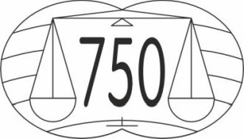
34 | IT54 | 意大利 | Convention on the Control and Marking of Articles of Precious Metals c/o PIC/S 26, rue de Saint Jean  Geneva  1203  Switzerland | 官方检验印章 | 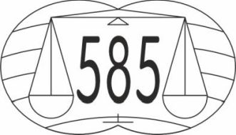
35 | IT55 | 意大利 | Convention on the Control and Marking of Articles of Precious Metals c/o PIC/S 26, rue de Saint Jean  Geneva  1203  Switzerland | 官方检验印章 | 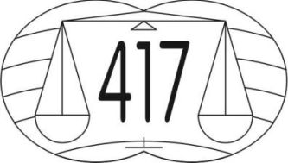
36 | IT56 | 意大利 | Convention on the Control and Marking of Articles of Precious Metals c/o PIC/S 26, rue de Saint Jean  Geneva  1203  Switzerland | 官方检验印章 | 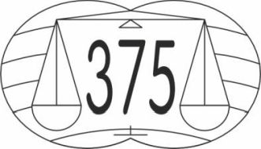
37 | IT57 | 意大利 | Convention on the Control and Marking of Articles of Precious Metals c/o PIC/S 26, rue de Saint Jean  Geneva  1203  Switzerland | 官方检验印章 | 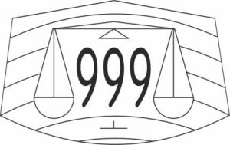
38 | IT58 | 意大利 | Convention on the Control and Marking of Articles of Precious Metals c/o PIC/S 26, rue de Saint Jean  Geneva  1203  Switzerland | 官方检验印章 | 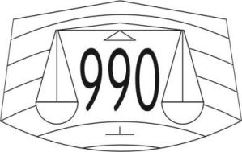
39 | IT59 | 意大利 | Convention on the Control and Marking of Articles of Precious Metals c/o PIC/S 26, rue de Saint Jean  Geneva  1203  Switzerland | 官方检验印章 | 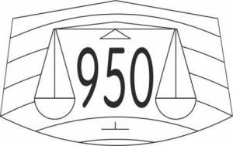
40 | IT60 | 意大利 | Convention on the Control and Marking of Articles of Precious Metals c/o PIC/S 26, rue de Saint Jean  Geneva  1203  Switzerland | 官方检验印章 | 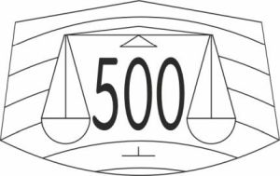
41 | IT61 | 意大利 | Convention on the Control and Marking of Articles of Precious Metals c/o PIC/S 26, rue de Saint Jean  Geneva  1203  Switzerland | 官方检验印章 | 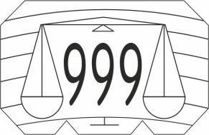
42 | IT62 | 意大利 | Convention on the Control and Marking of Articles of Precious Metals c/o PIC/S 26, rue de Saint Jean  Geneva  1203  Switzerland | 官方检验印章 | 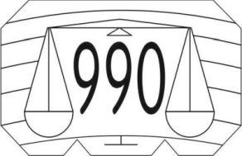
43 | IT63 | 意大利 | Convention on the Control and Marking of Articles of Precious Metals c/o PIC/S 26, rue de Saint Jean  Geneva  1203  Switzerland | 官方检验印章 | 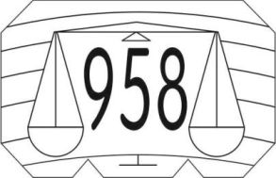
44 | IT64 | 意大利 | Convention on the Control and Marking of Articles of Precious Metals c/o PIC/S 26, rue de Saint Jean  Geneva  1203  Switzerland | 官方检验印章 | 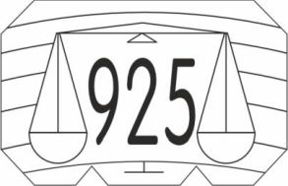
45 | IT65 | 意大利 | Convention on the Control and Marking of Articles of Precious Metals c/o PIC/S 26, rue de Saint Jean  Geneva  1203  Switzerland | 官方检验印章 | 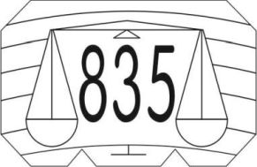
46 | IT66 | 意大利 | Convention on the Control and Marking of Articles of Precious Metals c/o PIC/S 26, rue de Saint Jean  Geneva  1203  Switzerland | 官方检验印章 | 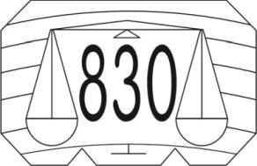
47 | IT67 | 意大利 | Convention on the Control and Marking of Articles of Precious Metals c/o PIC/S 26, rue de Saint Jean  Geneva  1203  Switzerland | 官方检验印章 | 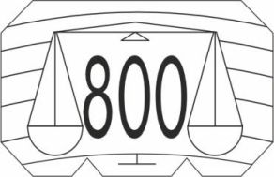
48 | IT68 | 意大利 | Convention on the Control and Marking of Articles of Precious Metals c/o PIC/S 26, rue de Saint Jean  Geneva  1203  Switzerland | 官方检验印章 | 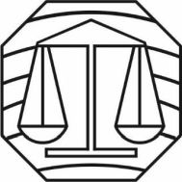
49 | MN1 | 蒙古国 | Intellectual Property Office of Mongolia Enkhtaivan avenue 30 Bayanzurkh District  Ulaanbaatar  13381  Mongolia | 国旗 | 
50 | MN2 | 蒙古国 | Intellectual Property Office of Mongolia Enkhtaivan avenue 30  Bayanzurkh District Ulaanbaatar  13381  Mongolia | 国家徽记 | 
51 | MN3 | 蒙古国 | Intellectual Property Office of Mongolia Enkhtaivan avenue 30 Bayanzurkh District Ulaanbaatar  13381  Mongolia | 国家徽记 | 
52 | RS21 | 塞尔维亚 | Convention on the Control and Marking of Articles of Precious Metals c/o PIC/S 26, rue de Saint Jean  Geneva  1203  Switzerland | 官方检验印章
53 | RS22 | 塞尔维亚 | Convention on the Control and Marking of Articles of Precious Metals c/o PIC/S 26, rue de Saint Jean  Geneva  1203  Switzerland | 官方检验印章
54 | RS23 | 塞尔维亚 | Convention on the Control and Marking of Articles of Precious Metals c/o PIC/S 26, rue de Saint Jean  Geneva  1203  Switzerland | 官方检验印章
55 | RS24 | 塞尔维亚 | Convention on the Control and Marking of Articles of Precious Metals c/o PIC/S 26, rue de Saint Jean  Geneva  1203  Switzerland | 官方检验印章
56 | RS25 | 塞尔维亚 | Convention on the Control and Marking of Articles of Precious Metals c/o PIC/S 26, rue de Saint Jean  Geneva  1203  Switzerland | 官方检验印章
57 | RS26 | 塞尔维亚 | Convention on the Control and Marking of Articles of Precious Metals c/o PIC/S 26, rue de Saint Jean  Geneva  1203  Switzerland | 官方检验印章
58 | RS27 | 塞尔维亚 | Convention on the Control and Marking of Articles of Precious Metals c/o PIC/S 26, rue de Saint Jean  Geneva  1203  Switzerland | 官方检验印章
59 | RS28 | 塞尔维亚 | Convention on the Control and Marking of Articles of Precious Metals c/o PIC/S 26, rue de Saint Jean  Geneva  1203  Switzerland | 官方检验印章
60 | RS29 | 塞尔维亚 | Convention on the Control and Marking of Articles of Precious Metals c/o PIC/S 26, rue de Saint Jean  Geneva  1203  Switzerland | 官方检验印章
61 | RS30 | 塞尔维亚 | Convention on the Control and Marking of Articles of Precious Metals c/o PIC/S 26, rue de Saint Jean  Geneva  1203  Switzerland | 官方检验印章
62 | RS31 | 塞尔维亚 | Convention on the Control and Marking of Articles of Precious Metals c/o PIC/S 26, rue de Saint Jean  Geneva  1203  Switzerland | 官方检验印章
63 | RS32 | 塞尔维亚 | Convention on the Control and Marking of Articles of Precious Metals c/o PIC/S 26, rue de Saint Jean  Geneva  1203  Switzerland | 官方检验印章
64 | RS33 | 塞尔维亚 | Convention on the Control and Marking of Articles of Precious Metals c/o PIC/S 26, rue de Saint Jean  Geneva  1203  Switzerland | 官方检验印章
65 | RS34 | 塞尔维亚 | Convention on the Control and Marking of Articles of Precious Metals c/o PIC/S 26, rue de Saint Jean  Geneva  1203  Switzerland | 官方检验印章
66 | RS35 | 塞尔维亚 | Convention on the Control and Marking of Articles of Precious Metals c/o PIC/S 26, rue de Saint Jean  Geneva  1203  Switzerland | 官方检验印章
67 | RS36 | 塞尔维亚 | Convention on the Control and Marking of Articles of Precious Metals c/o PIC/S 26, rue de Saint Jean  Geneva  1203  Switzerland | 官方检验印章
68 | RS37 | 塞尔维亚 | Convention on the Control and Marking of Articles of Precious Metals c/o PIC/S 26, rue de Saint JeanGeneva  1203  Switzerland | 官方检验印章
69 | RS38 | 塞尔维亚 | Convention on the Control and Marking of Articles of Precious Metals c/o PIC/S 26, rue de Saint Jean  Geneva  1203  Switzerland | 官方检验印章
70 | RS39 | 塞尔维亚 | Convention on the Control and Marking of Articles of Precious Metals c/o PIC/S 26, rue de Saint Jean  Geneva  1203  Switzerland | 官方检验印章
71 | RS40 | 塞尔维亚 | Convention on the Control and Marking of Articles of Precious Metals c/o PIC/S 26, rue de Saint Jean  Geneva  1203  Switzerland | 官方检验印章
72 | RS41 | 塞尔维亚 | Convention on the Control and Marking of Articles of Precious Metals c/o PIC/S 26, rue de Saint Jean  Geneva  1203  Switzerland | 官方检验印章
73 | RS42 | 塞尔维亚 | Convention on the Control and Marking of Articles of Precious Metals c/o PIC/S 26, rue de Saint Jean  Geneva  1203  Switzerland | 官方检验印章
74 | RS43 | 塞尔维亚 | Convention on the Control and Marking of Articles of Precious Metals c/o PIC/S 26, rue de Saint Jean  Geneva  1203  Switzerland | 官方检验印章
75 | RS44 | 塞尔维亚 | Convention on the Control and Marking of Articles of Precious Metals c/o PIC/S 26, rue de Saint Jean  Geneva  1203  Switzerland | 官方检验印章
76 | RS45 | 塞尔维亚 | Convention on the Control and Marking of Articles of Precious Metals c/o PIC/S 26, rue de Saint Jean  Geneva  1203  Switzerland | 官方检验印章
77 | RS46 | 塞尔维亚 | Convention on the Control and Marking of Articles of Precious Metals c/o PIC/S 26, rue de Saint Jean  Geneva  1203  Switzerland | 官方检验印章
78 | RS47 | 塞尔维亚 | Convention on the Control and Marking of Articles of Precious Metals c/o PIC/S 26, rue de Saint Jean  Geneva  1203  Switzerland | 官方检验印章

